

PURCHASE A COUSRE MANUAL

Client-Centred Approach
A client-centred approach in aesthetic practice places the client at the heart of all decisions and actions, prioritising their individual needs, values, and preferences. This philosophy goes beyond merely providing services — it fosters trust, collaboration, and emotional safety, which are all essential in personal and appearance-related procedures
Clients are more likely to share their honest concerns and expectations when they feel heard and understood. A client-centred approach encourages open, two-way communication, helping practitioners uncover underlying motivations, such as low self-esteem or body image issues, which may influence the client’s desire for aesthetic enhancement.
Each client has unique anatomical features, medical history, and aesthetic goals. A clientcentred approach enables practitioners to design customized treatment plans that align with the client’s realistic expectations, thus increasing the likelihood of satisfaction and reducing the risk of dissatisfaction or complaints.
By engaging clients in shared decision-making, they are empowered to take ownership of their treatment journey. Clients who feel in control are more likely to feel confident and satisfied with their choices, which positively impacts their overall experience and posttreatment perception.
Aesthetic treatments often involve emotional vulnerability. Practitioners who employ empathy and emotional intelligence build a rapport with clients, fostering psychological comfort that enhances the overall experience — from consultation through recovery.



Physical Examination of the Client
A comprehensive physical examination is a critical step in ensuring both client safety and optimal outcomes in aesthetic practice.
A thorough assessment helps to identify any underlying health conditions, allergies, or contraindications (e.g., active infections, autoimmune disorders, blood clotting disorders) that may affect the safety or effectiveness of the procedure. Overlooking such conditions could result in complications or adverse reactions.
Skin tone, elasticity, thickness, and underlying structure significantly influence treatment choice, technique, and expected results. For example, dermal filler volume and placement differ between clients with thin versus thick skin. A physical examination allows for accurate anatomical mapping.
Establishing a clear baseline allows for proper documentation and comparison postprocedure. This is especially useful for tracking outcomes, identifying improvements, or recognizing complications such as bruising, swelling, or asymmetry.
Every face or body is different, and physical examination allows for a tailored plan — respecting facial symmetry, volume loss, muscle movement, and proportion. This reduces the risk of unnatural results and enhances satisfaction.
From a legal standpoint, failing to carry out a physical assessment could be considered negligent. Ethical practice dictates that client safety and suitability must be determined before proceeding with any procedure.

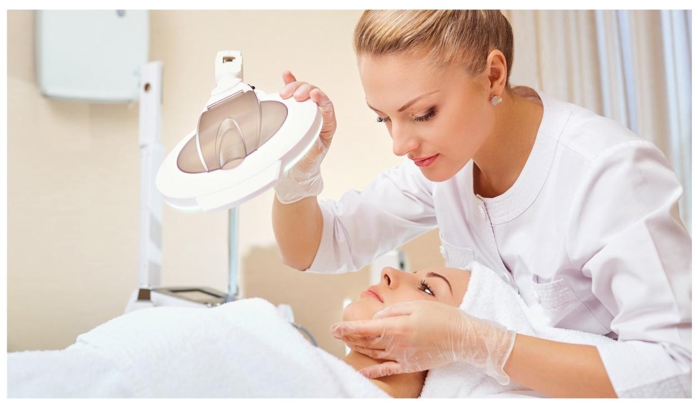

Informed Consent
Supporting clients through informed decision-making is an ethical imperative in aesthetics. It ensures autonomy and improves satisfaction and safety across all stages of care.
Clients should receive written and verbal information on how to prepare for the procedure. This includes avoiding certain medications (e.g., blood thinners), understanding fasting requirements, or taking antiviral medication for those with a history of cold sores.
Practitioners must explain the purpose of these instructions and their impact on outcomes and safety. Visual aids, FAQs, and consultations can be used to support understanding.
During treatment planning, clients must be informed about:
- The proposed procedure and how it works.
- Risks, side effects, and complications.
- Alternatives to the chosen treatment.
- The expected outcomes and limitations.
Consent should be obtained in a non-coercive environment, allowing time for questions and reflection. This ensures decisions are voluntary and educated rather than impulsive or pressured.

Clients need to understand post-treatment guidelines (e.g., no exercise, sun exposure, or alcohol) and the rationale behind them. Practitioners should provide both verbal and written aftercare instructions, follow-up support, and emergency contact details in case of adverse reactions.
Empowering clients with this knowledge supports healing, optimises results, and builds confidence in the care process.

Providing Clients Opportunities to Reflect
Reflection time is a powerful tool that supports emotional clarity and ethical practice in the aesthetic journey.
Clients given time to reflect are more likely to consider the risks, benefits, and alternatives thoroughly, reducing the likelihood of regret. This can include a mandatory ‘cooling-off’ period between consultation and treatment, especially for first-time or invasive procedures.
Aesthetic procedures can be emotionally driven, often influenced by societal pressure, recent life events, or emotional distress. Reflection helps clients assess whether the desire for change is consistent or reactive.
During the reflection period, clients can digest information provided during the consultation and temper unrealistic expectations. This often leads to more satisfaction with outcomes.
Providing space for reflection demonstrates respect for the client’s autonomy. It shifts the practitioner from a sales-driven mindset to a patient advocate, which enhances professionalism and trust.

Timescales in Relation to Aesthetic Treatments
Several clinical and non-clinical factors influence the timing and scheduling of aesthetic procedures, and understanding these helps in managing client expectations and ensuring safety.
Underlying health issues or current skin conditions may require postponement. For example, clients on blood thinners or with active acne may not be suitable for immediate treatment and may need medical management first.
Different treatments require different preparation and recovery periods. For instance, deep chemical peels or laser resurfacing demand longer recovery than Botox injections.
Combining multiple procedures (e.g., fillers and thread lifts) may require staging over several weeks.

Some procedures involve swelling, bruising, or redness that may take days or weeks to subside. Clients often want to align treatments with personal or professional schedules, such as avoiding visible signs of treatment during holidays or weddings.
Protocols such as antiviral prophylaxis, skin priming, or hydration may be required days before a procedure. Post-treatment care, such as avoiding sun exposure or massage, may influence when clients can return to normal activities.
In some regions, there may be mandatory waiting periods for cosmetic treatments, especially for minors or invasive procedures. Additionally, availability of trained staff, clinic space, and equipment also dictate scheduling.
Mental readiness is as important as physical preparation. Timescales may be extended if a client shows signs of emotional distress, anxiety, or body dysmorphic disorder, requiring referral or further discussion.

Effects of Ageing on Facial Characteristics and Morphology
As clients age, their facial structure undergoes gradual yet significant changes. These changes are multi-layered, affecting the skin, fat, muscle, and bone. One of the earliest visible signs of ageing occurs in the skin, where collagen and elastin production decrease, leading to fine lines, wrinkles, and laxity. The dermis thins, the skin becomes less hydrated due to diminished hyaluronic acid, and cellular turnover slows. Subcutaneous fat also shifts and depletes with age, particularly in the midface, temples, and jawline. This causes hollowing under the eyes, deepening of nasolabial folds, and the appearance of jowls. Underlying muscles may weaken or become hyperactive, contributing to dynamic wrinkles such as crow’s feet or frown lines. Additionally, skeletal resorption, especially in the maxilla and mandible, alters the foundational structure of the face, further impacting its contours and symmetry. Understanding these processes allows practitioners to design personalised treatment plans that target volume loss, skin quality, and facial proportion effectively.

Obtaining Relevant Client Information
Comprehensive client assessment begins with gathering relevant information. This includes demographic data, detailed medical history, current medications, allergies, prior aesthetic treatments, lifestyle habits, and psychosocial background. The aim is to understand the whole person, not just the area being treated. Encourage learners to use structured consultation forms, ask open-ended questions, and adopt a non-judgmental, empathetic tone. For example, asking, “What are you hoping to achieve with this treatment?” opens up discussion about expectations and motivations. Information gathered during this stage informs every subsequent decision — from choosing products and techniques to identifying risks or red flags.

Impact of Health Conditions on Aesthetic Procedures
A thorough understanding of the client’s health is critical in aesthetic medicine, as various medical conditions can influence the safety and effectiveness of treatment. For example, individuals with autoimmune disorders may have unpredictable healing responses or higher risks of complications, making certain procedures unsuitable. Those on anticoagulants or with cardiovascular conditions are at increased risk for bruising or bleeding, especially during injectable treatments. Clients with poorly controlled diabetes may experience delayed healing and a higher risk of post-procedural infections. In terms of dermatological health, active acne, eczema, or rosacea may worsen following procedures like chemical peels or microneedling if not properly managed. Equally important are psychological conditions, such as body dysmorphic disorder (BDD), which may render a client unsuitable for aesthetic treatment until mental health issues are addressed. Teaching learners to assess these conditions critically will help ensure safe and ethical practice.

Client’s Aesthetic and Medical History
Analysing the client's history allows practitioners to determine treatment suitability and identify any contraindications. This includes reviewing past treatments, medical diagnoses, allergies, and psychological wellbeing. Learners should be taught how to critically assess this data: for instance, a client with a history of cold sores would need antiviral prophylaxis before perioral treatments. Similarly, a client with unrealistic expectations or excessive previous treatments may need to be declined or referred. Learners must also practice clinical reasoning to justify their decisions — such as determining that a client is unsuitable for dermal fillers due to blood thinning medication or uncontrolled autoimmune disease. This evaluation supports safe, evidence-based practice and fosters transparent client communication.
Clients must be fully informed of all potential outcomes, including common side effects and rare but serious complications. Teaching learners to communicate this clearly and ethically is essential. Common side effects include swelling, redness, bruising, or tenderness, which usually resolve within days. However, learners must also be trained to explain more serious risks — such as vascular occlusion, allergic reactions, granulomas, or skin necrosis — especially with injectable treatments. Encouraging the use of visuals, analogies, and written consent forms can enhance understanding. This discussion builds trust and ensures that the client consents based on full understanding, rather than impulse or misinformation.

Risk Mitigation Strategies
While no procedure is entirely risk-free, many risks can be mitigated through proper planning and clinical best practices. Learners should be taught to explain these strategies to clients clearly. For example, using aseptic techniques, precise injection methods, product knowledge, and facial anatomy awareness reduces the likelihood of complications. Risk mitigation also includes post-procedural care, such as advising clients to avoid alcohol, strenuous exercise, or sun exposure. Clients should also be given clear instructions on recognising complications and when to seek help. Teaching learners to communicate these steps not only enhances client safety but also reflects professional competence and preparedness.

Referral Procedures
There are situations when a client is not suitable for treatment or when complications arise that require specialist intervention. Learners must be able to identify when and how to refer clients appropriately. This includes referral to a GP for medical clearance, a dermatologist for skin conditions, or a psychologist for suspected BDD or anxiety-related concerns. Practitioners should not attempt to treat conditions outside their scope or competence. Instead, clear documentation and respectful communication about referral decisions help preserve the client-practitioner relationship. Embedding referral protocols into teaching ensures learners understand both their professional boundaries and responsibilities.

Support Pathways Based on Client Needs
Clients may require additional support beyond the aesthetic procedure itself. Teaching learners to explore and justify support options is crucial to holistic practice. This might involve referring to mental health services for those struggling with self-image, recommending dermatological support for chronic skin issues, or suggesting nutritional guidance for those with lifestyle-related skin concerns. Learners should be taught to assess individual needs and offer referrals sensitively, ensuring clients feel supported rather than dismissed. Understanding local pathways, NHS services, and private sector options gives learners the tools to provide continuity of care that goes beyond the treatment room.

Working Within Own Competence and Scope of Practice
Working within one's scope of practice and competence is a fundamental principle of safe, ethical, and professional aesthetic care.
Aesthetic procedures, although often non-surgical, can carry risks such as vascular occlusion, allergic reactions, or nerve damage. Practitioners who operate beyond their training may not recognise or manage these complications appropriately, endangering client safety.
Regulatory bodies and insurers require practitioners to adhere to defined scopes based on their qualifications and training. Practicing beyond one’s competence could result in disciplinary action, loss of insurance coverage, or legal consequences.
Clients place trust in practitioners to act responsibly. By working only within one's competence, professionals uphold a high standard of care, which preserves reputation and trust in both the individual and the wider industry.
Staying within current competence does not preclude growth. Practitioners are encouraged to upskill through accredited courses before expanding their service offerings, thereby ensuring safe and informed practice evolution.

